**THE MOST POPULAR QUESTIONS ABOUT LIGHTROOM PRESETS.**

**Q: How to install presets to Lightroom?**

**A:** You should make the following steps:

* Turn off the Lightroom
* Unzip the presets you downloaded to somewhere on your computer you can find
* Windows user: C:\Users\ <username>\AppData\Roaming\Adobe\Lightroom\Develop Presets
* Mac OS user: <your home folder>/Library/Application Support/Adobe/Lightroom/Develop Presets
* Create folder with preferred name
* Copy to these folder downloaded presets

Can’t find it? Open the LR preferences, head to “Presets”, and click on the “Show Lightroom Presets Folder” button.

**Alternative way**

Double click on preset file, and it will appear in User Presets folder in Lightroom.

**Or**

Open Lightroom, go to develop mode, right click on presets folder and select import presets.

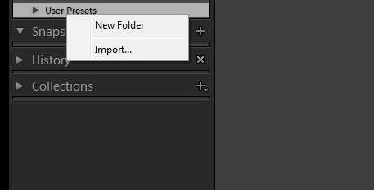

**Q: How to remove orange\red\yellow skintones?**

**A:** It’s pretty easy, just make the following steps:

* Apply the preset you want
* Go to HSL panel > Saturation
* Click on little circle button named “Adjust saturation by dragging in the photo” *red arrow

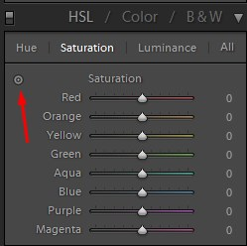

* Move your mouse to the skin, press the left click button and drag, down to reduce saturation, up to increase

**Q: I have just apply the preset, and the image become to cold, what I have to do?**

**A:** When you use preset or action, and the image is very cold or very warm, just change a temperature (White Balance) of this image.



**This FAQ will be updated, just ask me a question and i will answer.**